**Fanmade V2 Project Setup**

**8/5/2012**

1. GitHub:

URL: <https://github.com/mrahmani/FanmadeV2>

Create a Github account if you don’t have one already, you’ll need it to access the project

1. TortoiseSVN: <http://tortoisesvn.net/downloads.html>

SVN client and GUI, we’ll be using it to check out the project from source control and check in changes.

NOTE: 64-bit systems MUST download and use the 64-bit version of Tortoise.

1. AnkhSVN (Optional but preferred): <http://ankhsvn.open.collab.net/>

This gives us full SVN integration in Visual Studio. Makes it MUCH simpler to check in project changes:

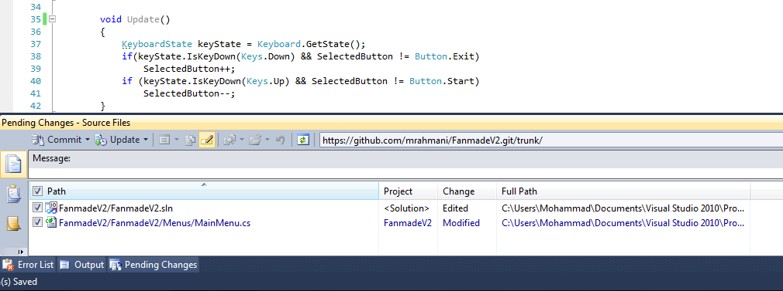

To set up Ankh:

1. Go to Tools -> Options -> Source Control, and set the current source control plugin to AnkhSVN
2. File -> Subversion -> Open from SVN
   1. Here you’ll input the directory to open the project from, you’ll want to paste in the project directory: <https://github.com/mrahmani/FanmadeV2.git/trunk/>
3. When you open the project the first time, a bunch of cache files may show up in the “Pending Changes” window – right click on them and hit “remove from pending changes”
4. PROFIT!